READING: KLASS Launch Team Roles

Console | Examples | Description of Launch Team Role
ET | Cryogenics, Materials, and Chemical Engineers | The External Tank (ET) console monitors the flow of liquid oxygen and liquid hydrogen to the main engines. ET engineers are concerned with maintaining just the right flow of cryogenics so the Shuttle can launch efficiently and safely.
ECLSS | Environmental Mechanical, Avionics, and Biomedical Engineers | 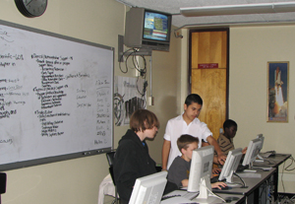  Engineers monitor and command the environmental and life support systems on the orbiter. This includes pressurization of the crew module, distribution of potable water, maintenance of breathing air quality, and functional verification of the operation of the avionics cooling system throughout the vehicle. The ECLSS is responsible for maintaining a comfortable environment for the astronauts while they are out of their space suits and in the orbiter's cabin.
Weather | Meteorologists, Launch Weather Officer, and Weather Technicians | These weather specialists monitor weather conditions to ensure safe launch. The KLASS Weather Display console is a simplified version of the Kennedy Space Center's Meteorological Interactive Data Display System known as MIDDS. MIDDS integrates diverse weather data on a single display, including weather radar and lightning strikes. This data helps forecasters determine if weather and lightning avoidance criteria are met. This data also helps the team make decisions about launch.
SSME | Mechanical, Chemical, and Aeronautical Engineers | 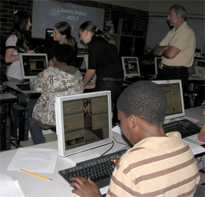  The Space Shuttle Main Engines (SSMEs) are the three main engines at the aft of the orbiter. They create the thrust needed to launch the orbiter into space. The main propulsion system (MPS) is connected to the main engines. It's comprised of piping, valves, and sensors that connect the ET to the orbiter and to the engines. This provides liquid oxygen and liquid hydrogen from the ET to the engines to create thrust. The SSME engineers monitor power output and propellant flow within the main engine. There are three SSME consoles, one for each of the Shuttle main engines. From each of these consoles, a Shuttle engineer can adjust fuel and oxidizer valves in order to produce the required amount of thrust for the Shuttle.

Console | Examples | Description of Launch Team Role
OBS | Medical Doctors, Surgeons, Biomedical Engineers, and Emergency Medical Staff | 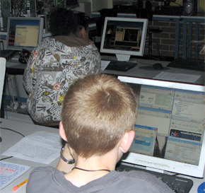  The KSC Physician, Crew Surgeon, and Biomedical Engineer maintain current medical data on each crew member in the event baseline data is needed in an emergency. This team is responsible for medical advice in event of a contingency. In addition to monitoring the astronaut vital signs, they also are responsible for emergency procedures for astronauts exiting the Shuttle and emergency crews responding on site. The OBS console displays an electrocardiograph of two designated flight crewmembers. It also shows these astronauts’ pulse, respiration, oxygen level, blood pressure, and temperature.
Integrated | Launch Director, Astronaut, or other roles as determined | The Launch Director (LD) monitors many different systems depending on where we are in the launch countdown and/or if there is an issue with a specific system. Calm, confident, and careful still define the people who give the ultimate "go" to launch a spacecraft. As the last decision-maker before the Space Shuttle engines and boosters ignite, the LD has the responsibility to say "no" if everything doesn't look and seem exactly right, even when the rest of the launch team says "go." It's the job of the LD to keep the spacecraft on the ground if we're not ready to go. Also, the role of the LD is to conduct the countdown for Space Shuttle missions. He or she leads 460 launch controllers, working in two firing rooms, checking and rechecking Shuttle systems before liftoff.
Teacher |  | The teacher console is the master console. It is an integrated view of the entire simulation.

